SIM808 V2.2.5 user manual V1.4

|  |  |  |
| --- | --- | --- |
| time | Descriptions | version |
| 2015/7/6 | initial | V1.2 |
| 2015/7/7 | Modify | V1.3 |
| 2015/10/6 | Modify | V1.4 |

***Getting Started***

A little preparation goes a long way, so make sure you’ve covered the following points:

* Regarding your cellular provider. Do you have coverage on a GSM 850 MHz, GSM 900 MHz, DCS 1800 MHz or PCS 1900 MHz network? When we say GSM that means 2G – not 3G, 4G or LTE. Will they allow the use of non-supported devices on the network? Some carriers will block IMEI numbers that were not provided by their sales channel. Or you may have to call the provider and supply the IMEI of your GSM module to allow it on the network. Finally, it would be wise to use either a prepaid or an account that offers unlimited SMS text messaging – you don’t want any large bills if things go wrong.
* Power. Do you have adequate power for your SIM808 module? Some shields will use more current (up to 2A), so you may need an external high-current supply. We needs 5V up to 2A or 9V 1A or 12V 1A into the onboard socket. Otherwise, check with your supplier
* Antenna. If your module/shield etc. doesn’t have an antenna – get one. You do need it.
* Insert the SIMCARD correctly
* And as always, please don’t make an auto-dialer

Furthermore, get the SIM800_Series_AT_Command_Manual_V1.07 (.pdf) and the SIM808_Hardware Design_V1.00 (.pdf), as we’ll refer to those throughout the tutorial.

* ***Power***

There is a DC socket on the shield, which is for a 5V power supply: The power pins are 5V and GND. The SIMCOM hardware manual for the module notes that it can draw up to 2A for short bursts. So get yourself a 5V 2A power supply and connect it via the DC socket.

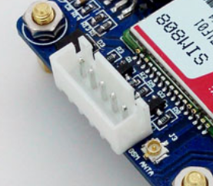

* ***SIM808 TTL Serial***

This shield has a set a TTL UART serial, which is capable with 5v system by default. When you want use a 3.3v or 2.85v system to control it, you should remove the 0R from the 5V side to the 2.85V side.

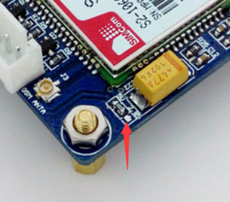

***Wow – all those rules and warnings?***

The sections above may sound a little authoritarian; however we want your project to be a success. Now, let’s get started…

***A quick test…***

At this point we’ll check to make sure your shield and locate and connect to the cellular network. So make sure your SIM card is active with your cellular provider: When you insert the SIMCARD, please refer the schematic diagram next to the SIMCARD socket

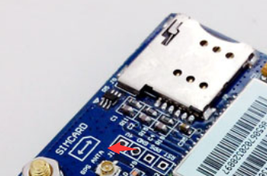

Then connect the USB-TTL module to the TTL UART. The hardware connection between the USB-TTL and SIM808 module is like this.

|  |  |
| --- | --- |
| **USB-TTL** | **SIM808** |
| **GND** | **GND** |
| **RXD** | **TXD** |
| **TXD** | **RXD** |

Then connect the 5V power to the DC socked *on the GSM shield* and then watch the following three LEDs:

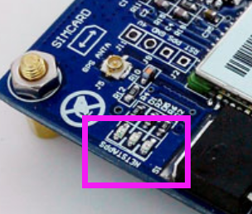

The bright “STA” LED will come on, and then the “NET” LED will blink once every 800 milliseconds- until the GSM module has found the network, at which point it will blink once every three seconds. The”PPS” LED is used to indicate the GPS is fixed or not. But the GPS function is closed by default, so there will be nothing until we do something to the GPS function. We will do some introduction next.

Nothing can happen until that magic three-second blink – so if that doesn’t appear after a minute, something is wrong. Check your shield has the appropriate power supply, the GSM antenna is connected correctly, the SIM card is seated properly and locked in- and that your cellular account is in order. Finally, you may not have reception in that particular area, so check using a phone on the same network or move to a different location.

***We will illustrate the usage of the module with an example of how to operate under GSM mode in the following section.***

We should connect the TTL-USB to the UART interface. When the two LEDs is lighting, it indicates that module is working, we can send AT command to control it.

Start the sscom.exe serial tool on PC, and perform operations as followed.

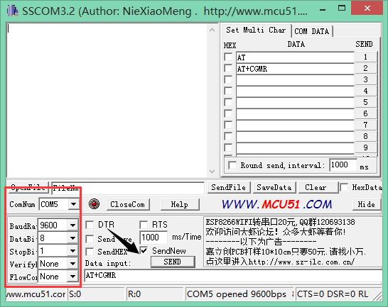

In this example, the ComNum is set to COM5. In practical application, please right click the icon MyComputer->Property->Device Manager, in order to check corresponding port number.

Fill in the Data input box with AT COMMAND, and click the button Send to transmit the command.

***GSM debugging***

***Connect the USB-TTL to the UART interface***

***Common command descriptions for message transmission***

|  |  |  |
| --- | --- | --- |
| **Commands** | **Descriptions** | **Return values** |
| AT | Make sure the module is working properly | AT OK |
| AT+CSCA? | Get the core number of message | +csca:”******” |
| AT+CMGF=1 | Select SMS message format | AT+CMGF=1 OK |
| AT+CMGS="15124532672" | Set the message transmission number and send SMS message. After receiving the symbol >, the message Hello World!(*) can be sent out | > |
| SIM808 test | The context of message | SIM808 test |
| 1A | This is a terminator. Before sending it out, you should check the option Send As Hex |  |
|  | Send successfully | +CMGS:* OK |

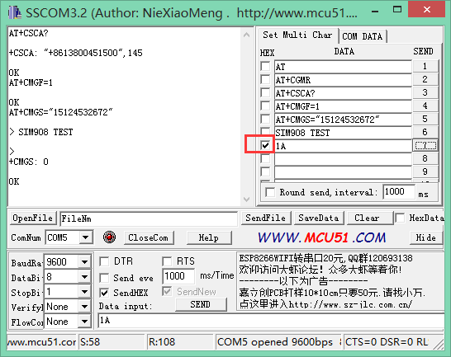

(For more detailed information about AT commands, please refer to SIM800_Series_AT_Command_Manual_V1.07)

***GPS debugging***

(For more detailed information about AT commands, please refer to SIM800 Series_GNSS_Application Note V1.00)

***Receive the NMEA0183 GPS data：***

User should send the commands listed above to turn on GPS power supply, reset to GPS and send out the GPS data.

* AT+CGNSPWR=1 (turn on GPS power supply)
*  AT+CGNSTST=1 (send out the GPS data)

Notices:

User should send the commands listed above to turn on GPS power supply If you do not known what is the NMEA0183 data, please search it on the internet or refer to SIM800 Series_GNSS_Application Note V1.00.

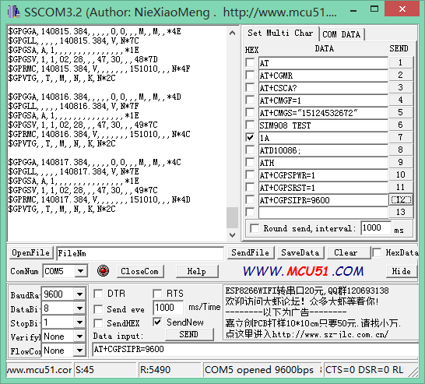

***Checking GPS information with NEMA GPS Demo***

Start the software NEMA GPS DEMO V2.2, as Figure 7 shows.

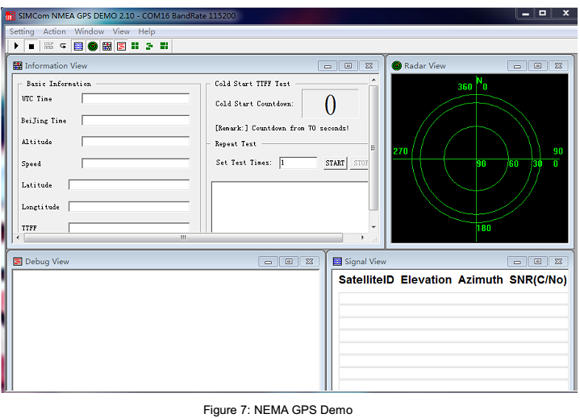

Open corresponding port: setting->port Setting, and set the port and Baud rate: 9600 (If the Baud rate of the module is modified to a certain value by sending AT+CGPSIPR command, the modified Baud rate should be used in here).

Select Action->run. Then, you can see the relative GPS information, as Figure 8 shows.

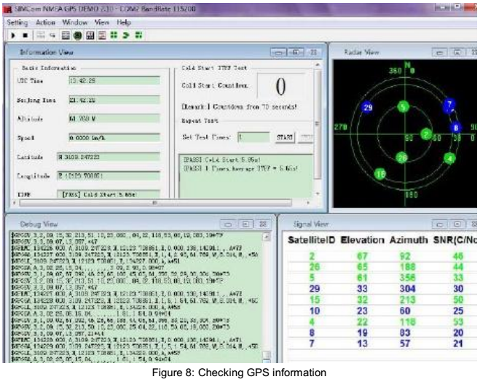

And then, when the GPS is fixed, the “PPS” LED will blink once every 1 second.